Wheels

* Omnivehicle
* Mecanum wheels
* Keep in mind of the manufacturing defects

Robotic manipulators

* Keep in mind of the constrained workspace
* Moment calculations are important, as they create constraints (can the motor generate enough torque?)

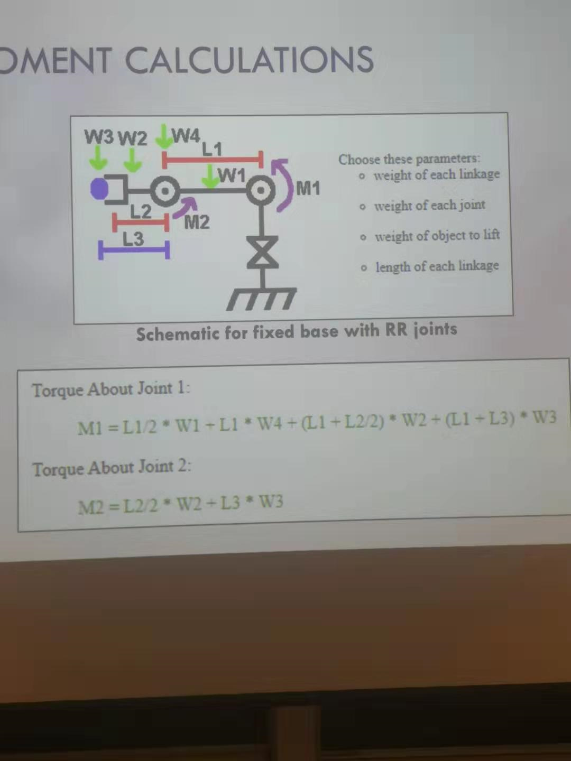

* Joints
  + Revolute (rotational)
  + Prismatic (linear fashion)
* Types of manipulator
  + Polar
  + Cylindrical
  + Carteisan
    - Three prismatic joints, consider the workspace that you are constrained in
  + Jointed-arm
  + Scara
    - Revolute-revolute-prismatic joints
  + Anthropomorphic
    - Three revolute joints

Gear ratio: mechanical advantage

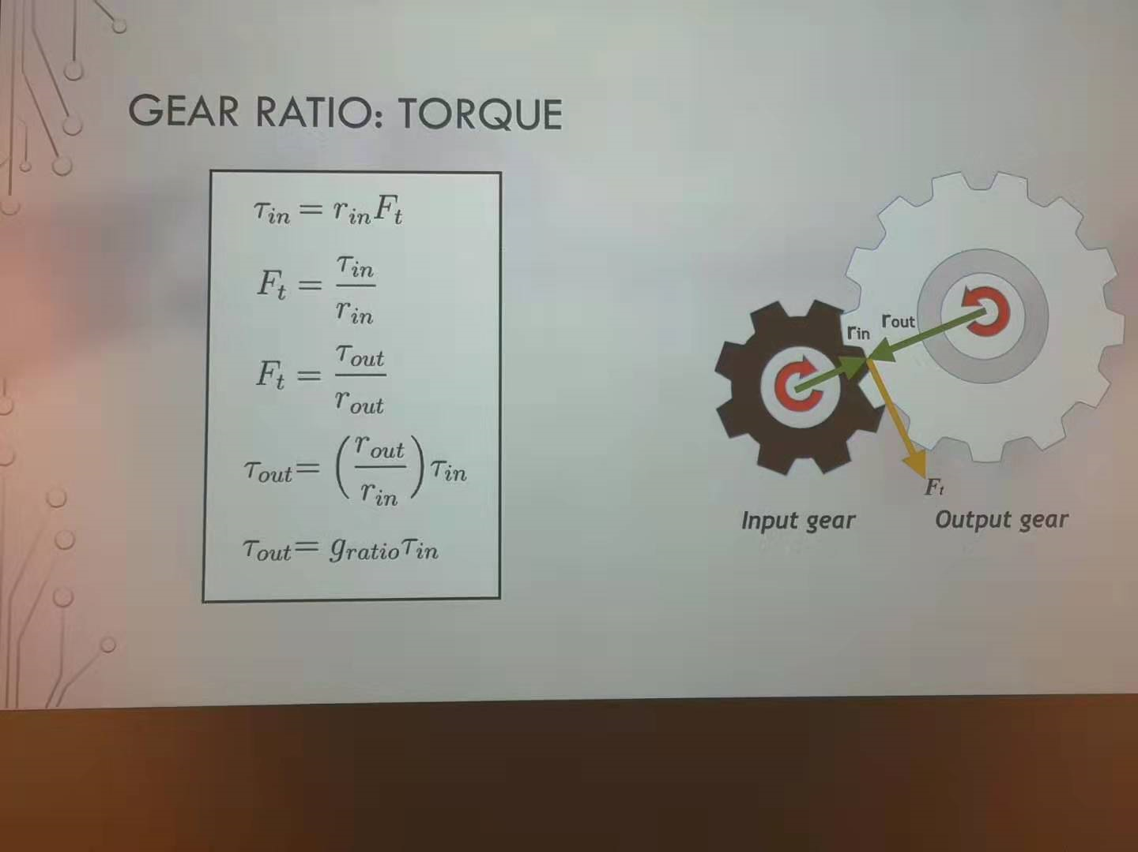

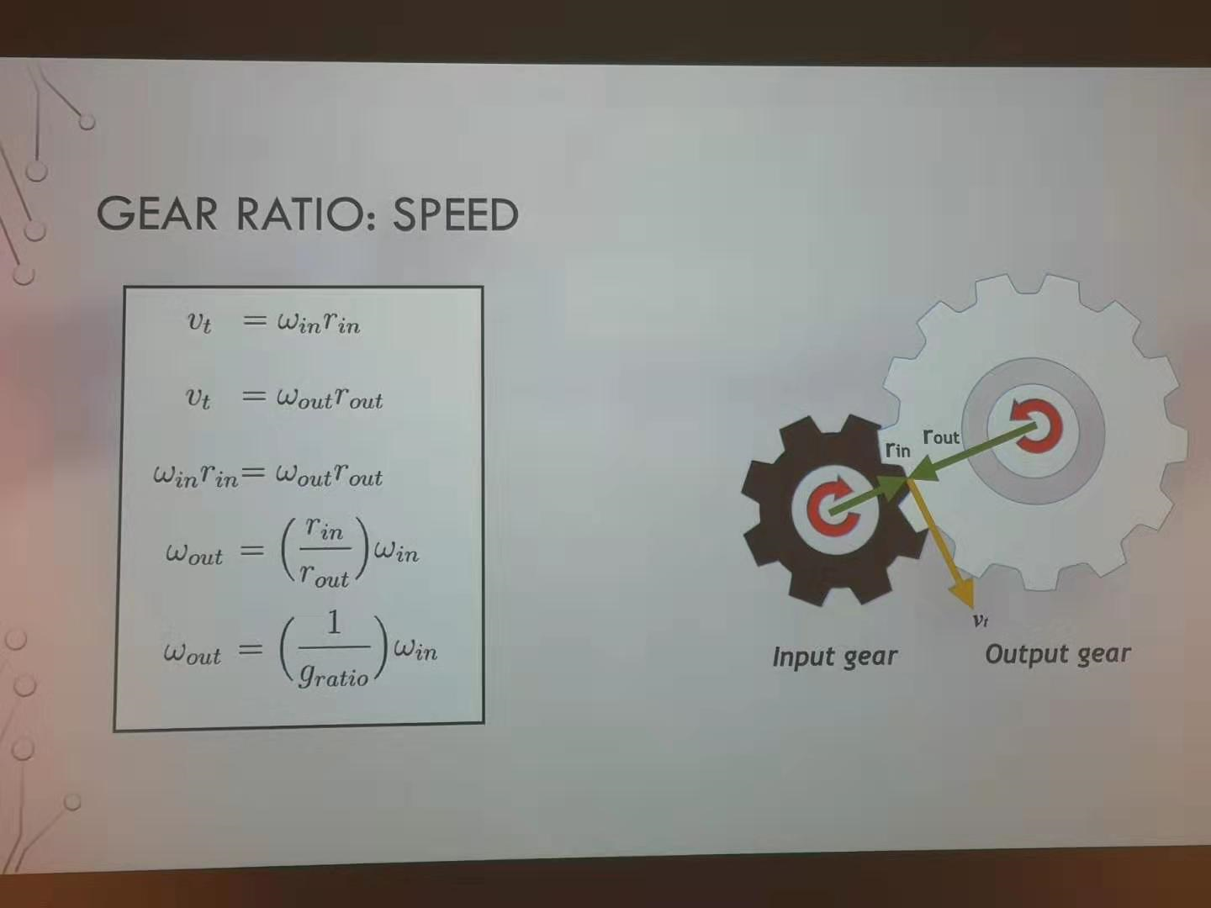

* Trade off between speed or torque

Linkage

* Affects something far from the sensor without it being there

Problem to consider

* During integration phase, keep in mind that other circuit components also consume power. Testing individual components in the beginning is fine, but at the end the power is distributed to every component and everything has to work in harmony.

Materials purchasing

* <https://www.mcmaster.com/> buy from there OR download CAD from there and 3D printing
* <https://www.digikey.ca/products/en> Free shipping for $100+